AWS LAB - 1: Introduction to AWS IAM

Vishakha Maruti Sonmore (CSULB ID: 032188141)

College of Business, California State University, Long Beach

Course Number: I S 602 Sec08 12348 Management Information Systems

Instructor: Dr. Santos Galvez

Due date: 15-Oct-2023

**Lab 1: Introduction to AWS IAM**

AWS Identity and Access Management (IAM) is a web service that enables Amazon Web Services (AWS) customers to manage users and user permissions in AWS. With IAM, you can centrally manage users, security credentials such as access keys, and permissions that control which AWS resources users can access.

**Task 1: Explore the Users and Groups**

During this laboratory session, we were introduced to AWS Identity and Access Management (IAM), a service designed for the management of user access to AWS resources. We had the opportunity to delve into pre-established IAM Users and Groups, examining their permissions, and gaining insights into IAM policies. Notably, we explored three specific groups: EC2-Admin, EC2-Support, and S3-Support, each of which had associated policies that granted varying degrees of access. This exercise aimed to enhance our comprehension of the structural organization of IAM users and groups and the mechanisms by which permissions are allocated within the AWS environment.

* 1. Start LAB

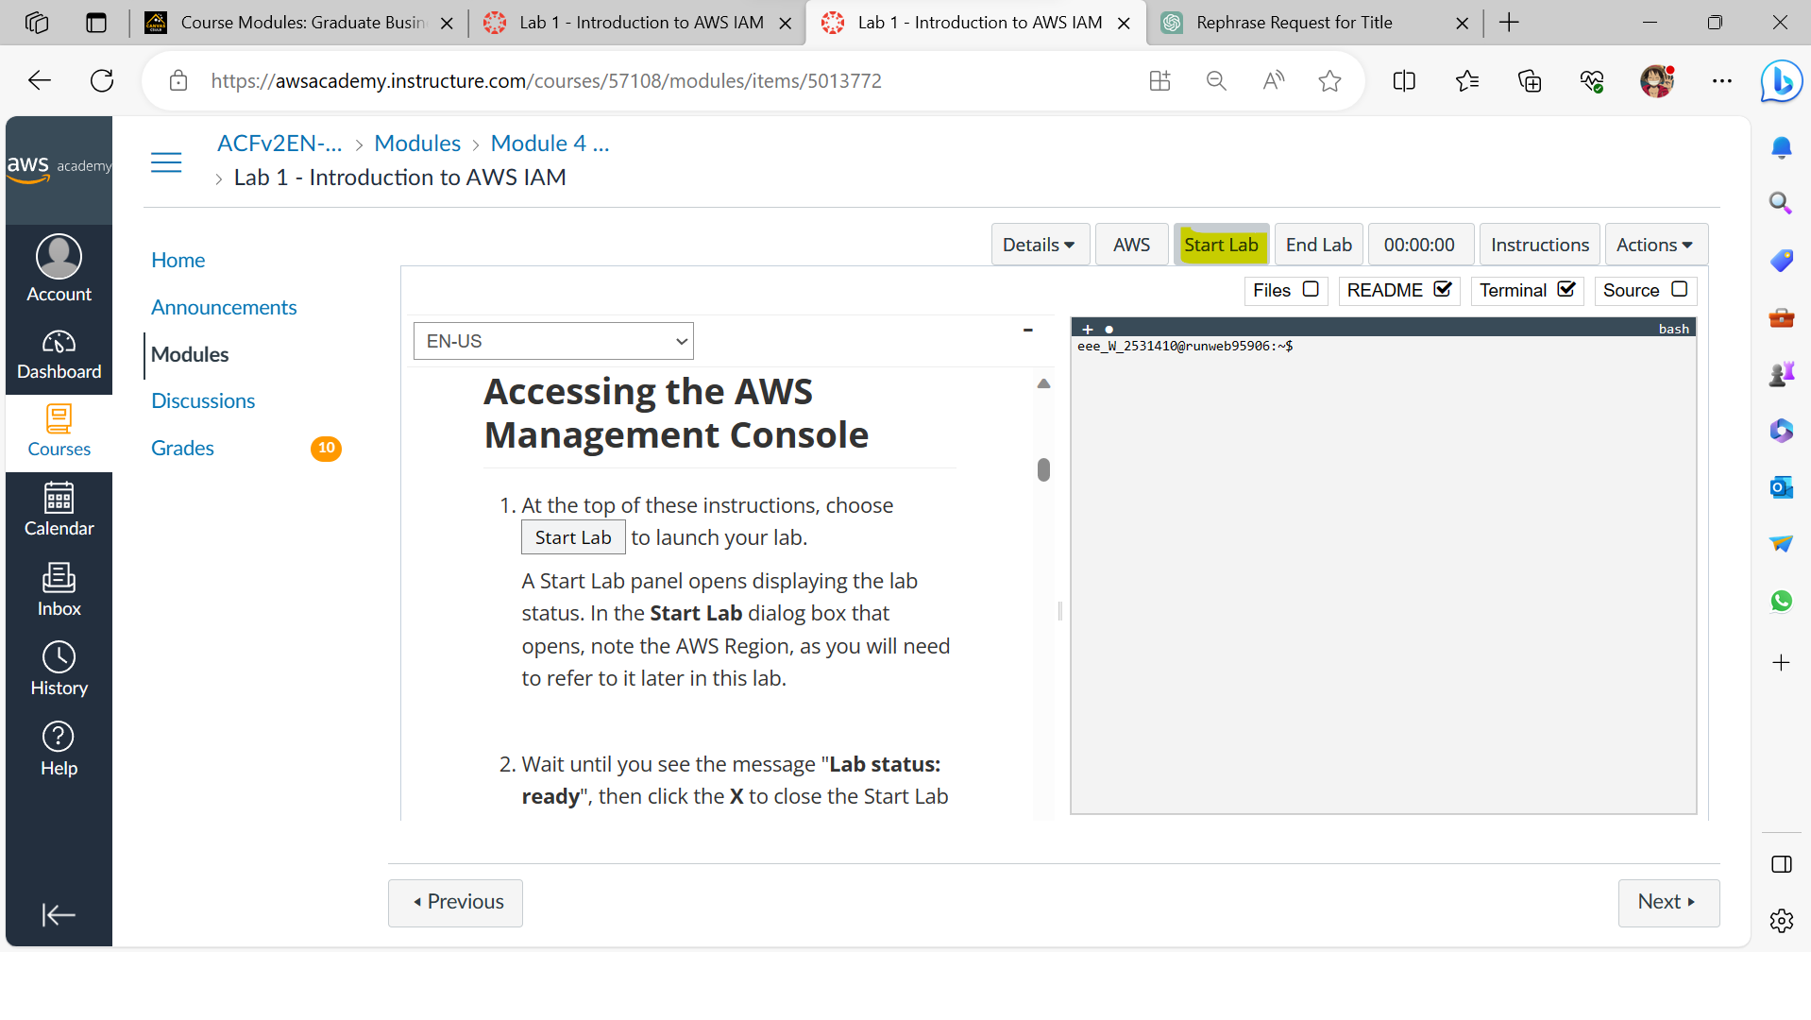

* 1. A Start Lab panel opens displaying the lab status

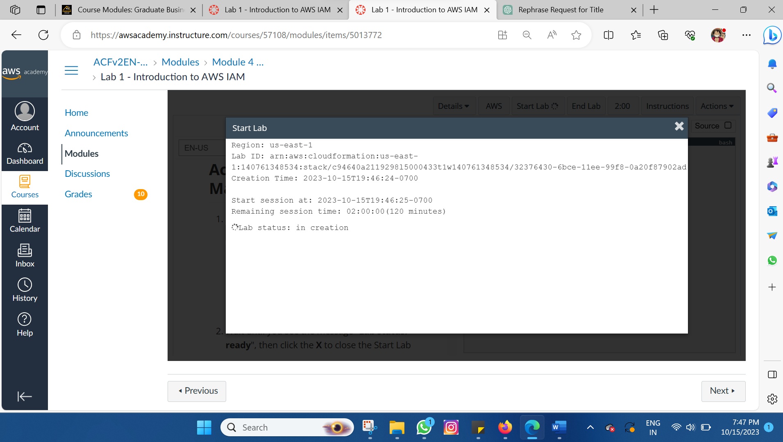

* 1. Wait until you see the message "Lab status: ready", then click the X to close the Start Lab panel.

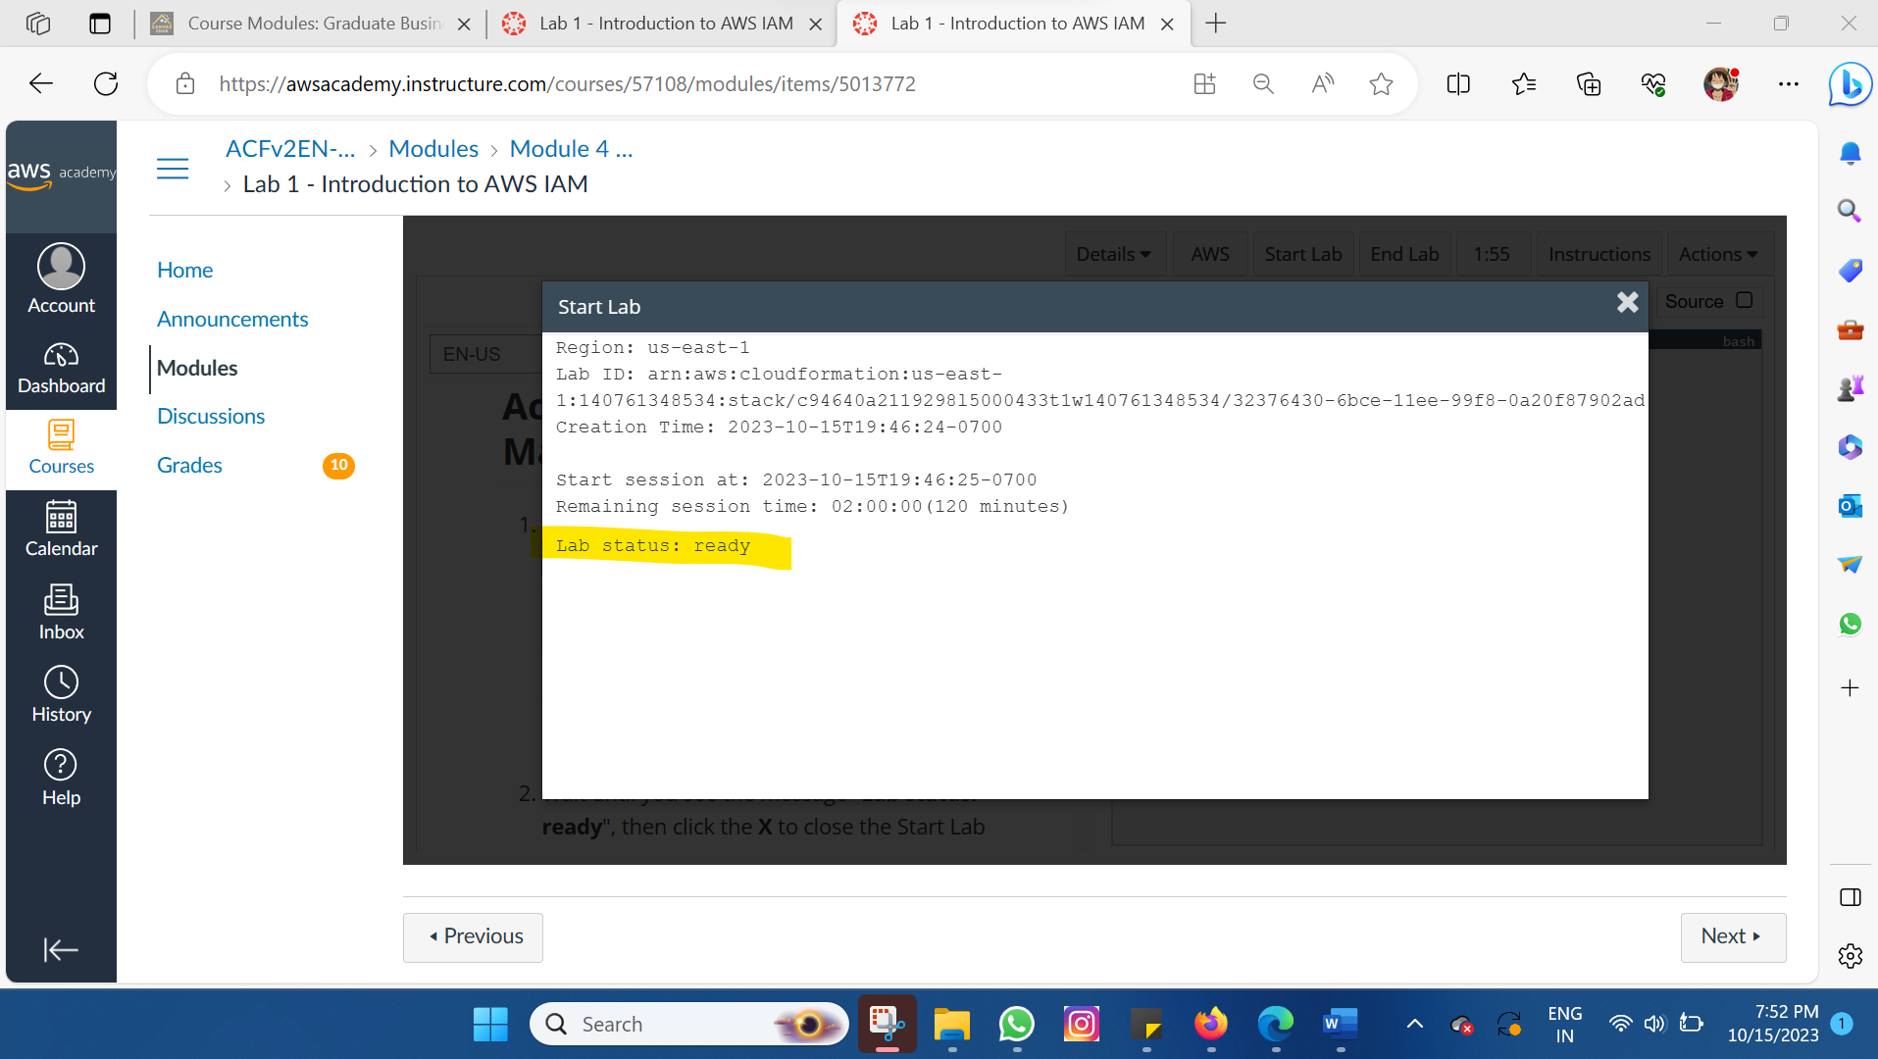

1.4 At the top of these instructions, choose AWS. This will open the AWS Management Console in a new browser tab. The system will automatically log you in.

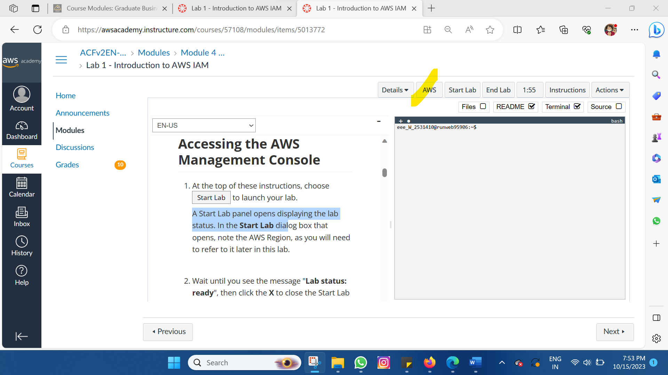

* 1. In the AWS Management Console, on the Services menu, select IAM.

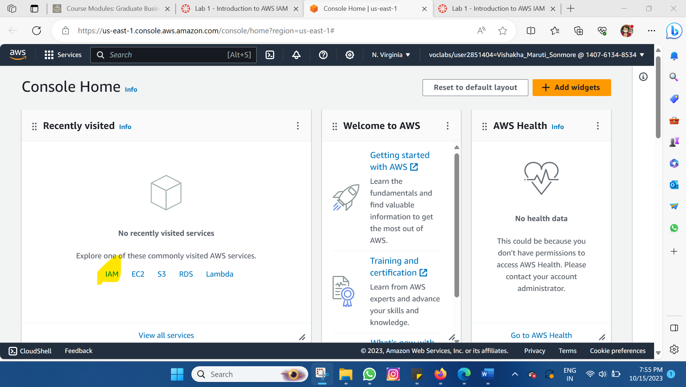

* 1. n the navigation pane on the left, choose Users. The following IAM Users have been created for you: user-1, user-2, user-3

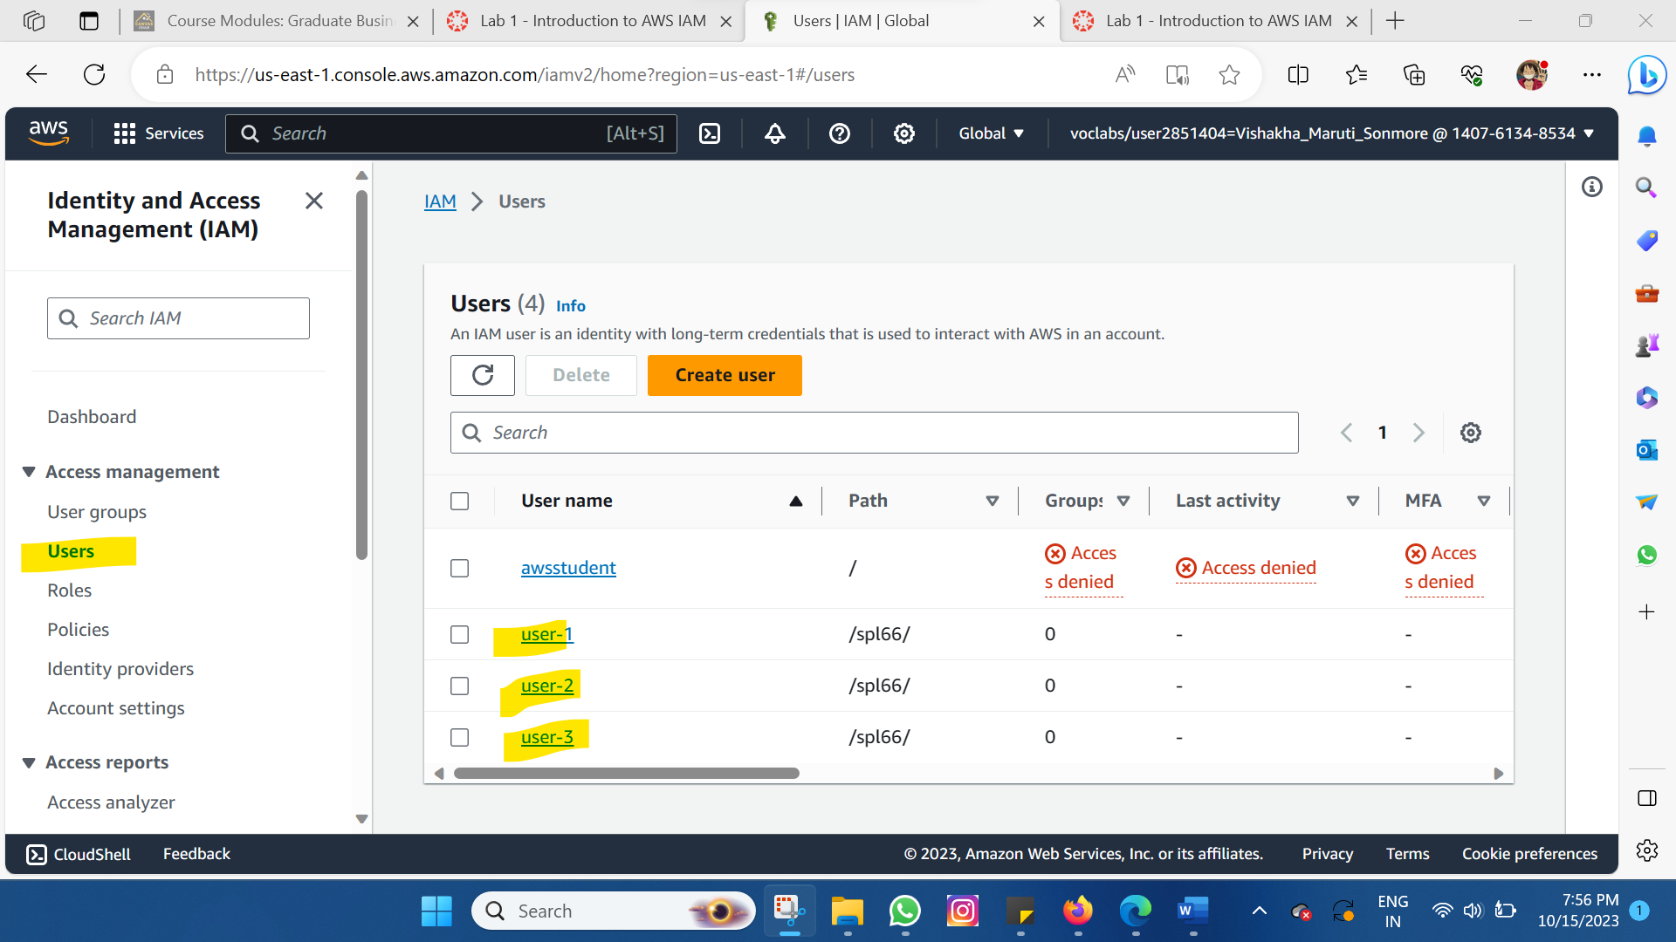

* 1. Choose user-1. This will bring to a summary page for user-1. The Permissions tab will be displayed.

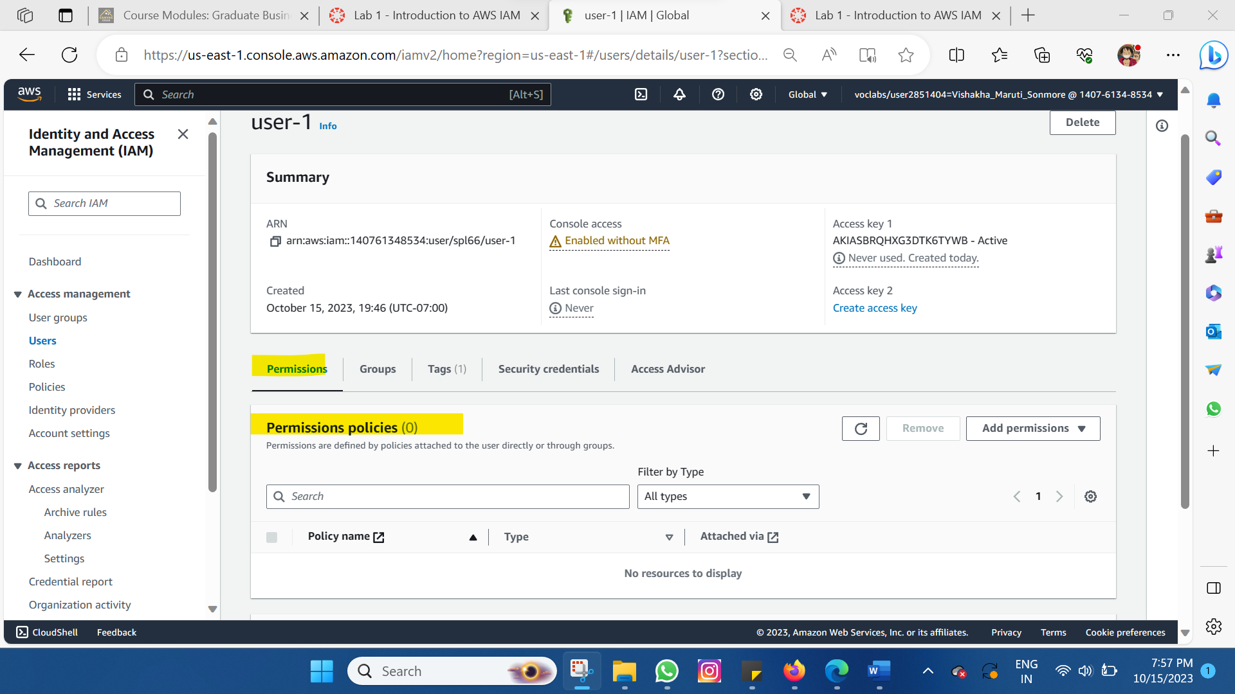

* 1. Choose the Groups tab. user-1 also is not a member of any groups.

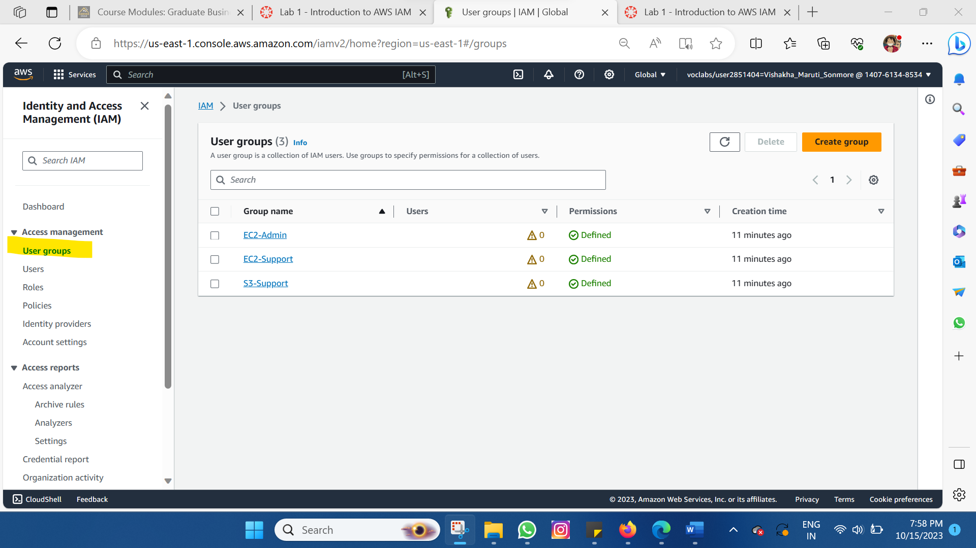

* 1. Choose the Security credentials tab. user-1 is assigned a Console password.

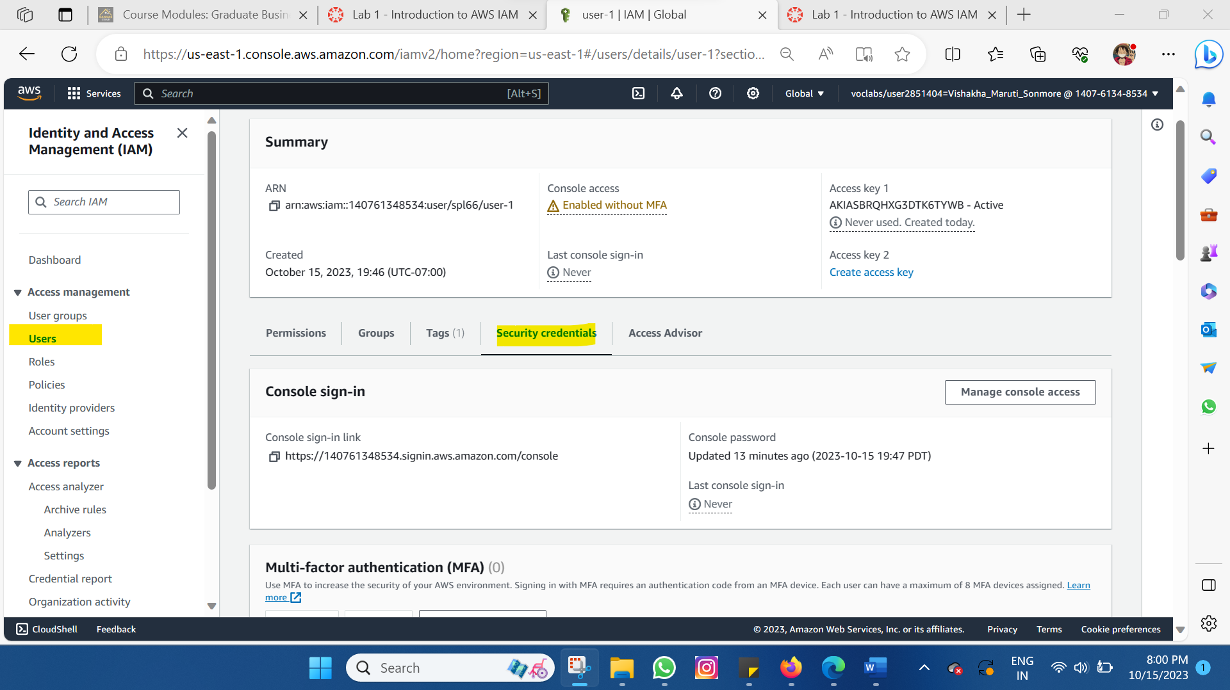

1.9 In the navigation pane on the left, choose User groups.

The following groups have already been created for you: EC2-Admin, EC2-Support, S3-Support

Choose the EC2-Support group. This will bring you to the summary page for the EC2-Support group.

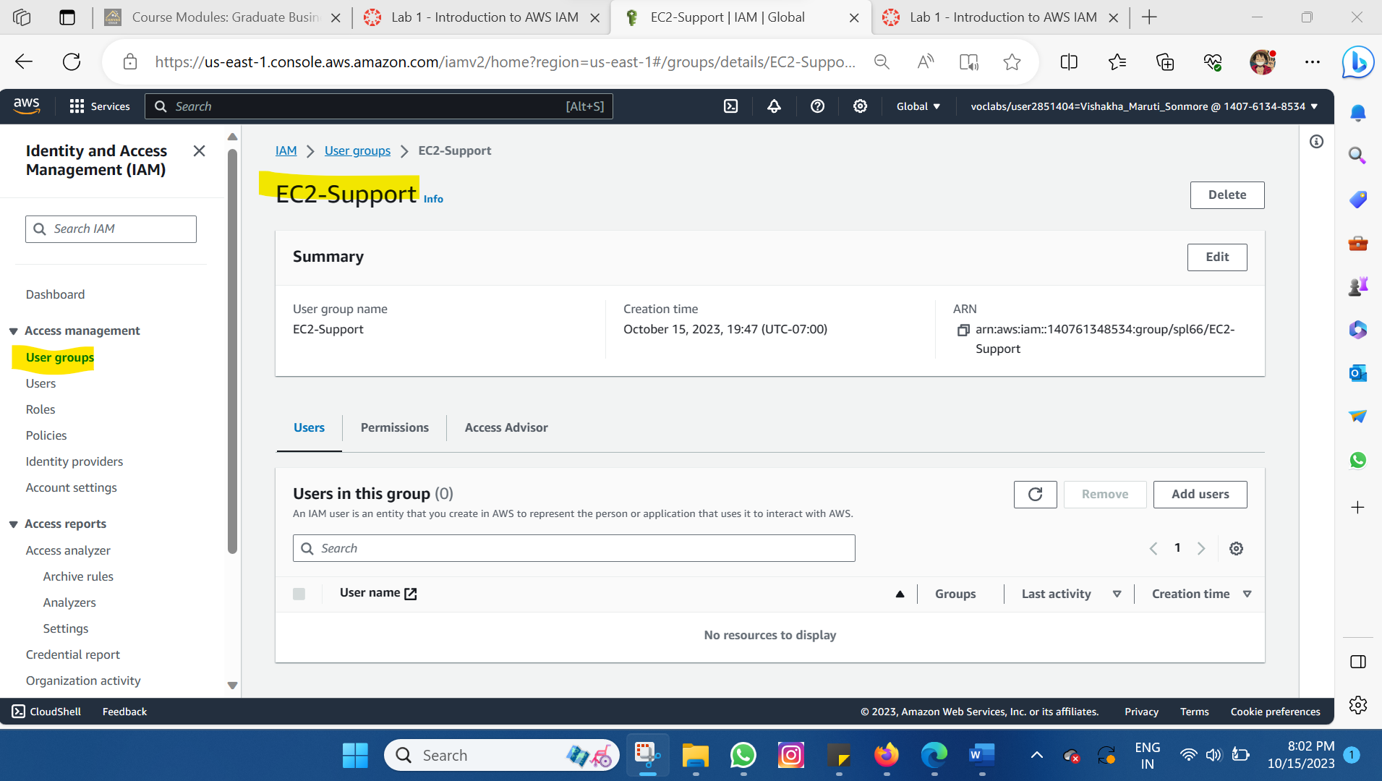

1.10 Choose the Permissions tab.

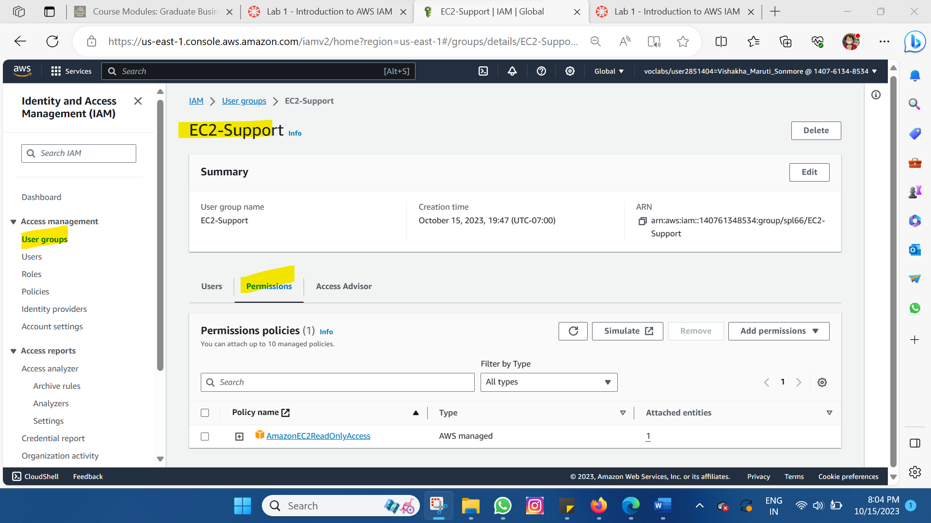

1.11 Choose the plus (+) icon next to the AmazonEC2ReadOnlyAccess policy to view the policy details.

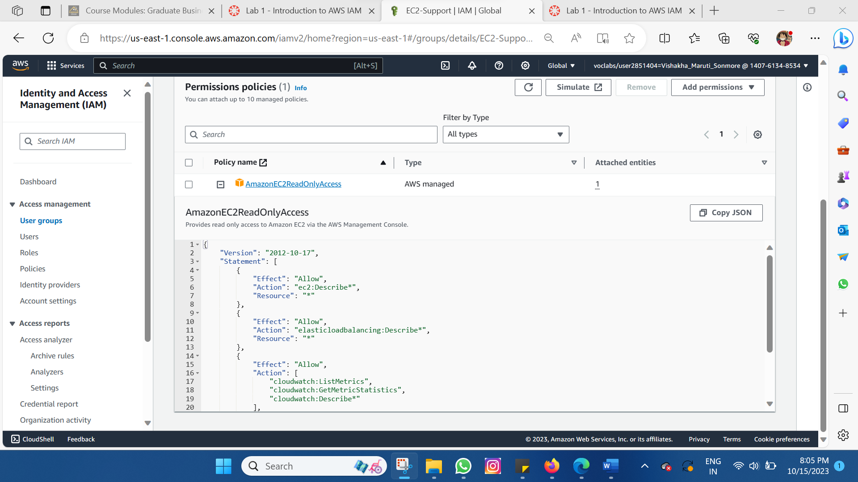

1.12 Choose the EC2 Admin group and then choose the Permissions tab.

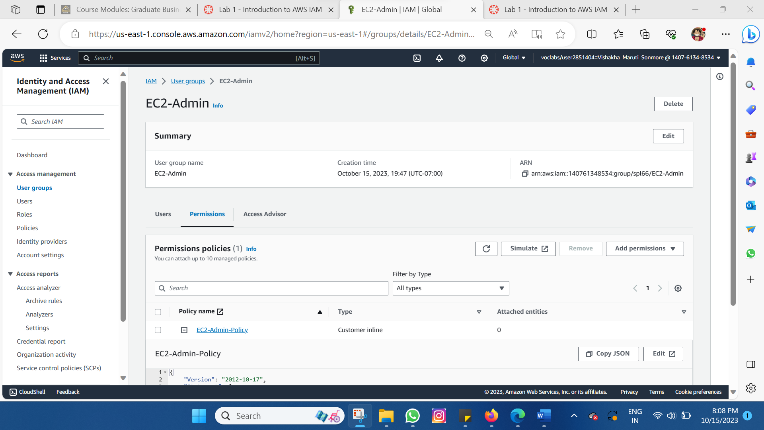

1.12 Choose the EC2 Admin group and then choose the Permissions tab.

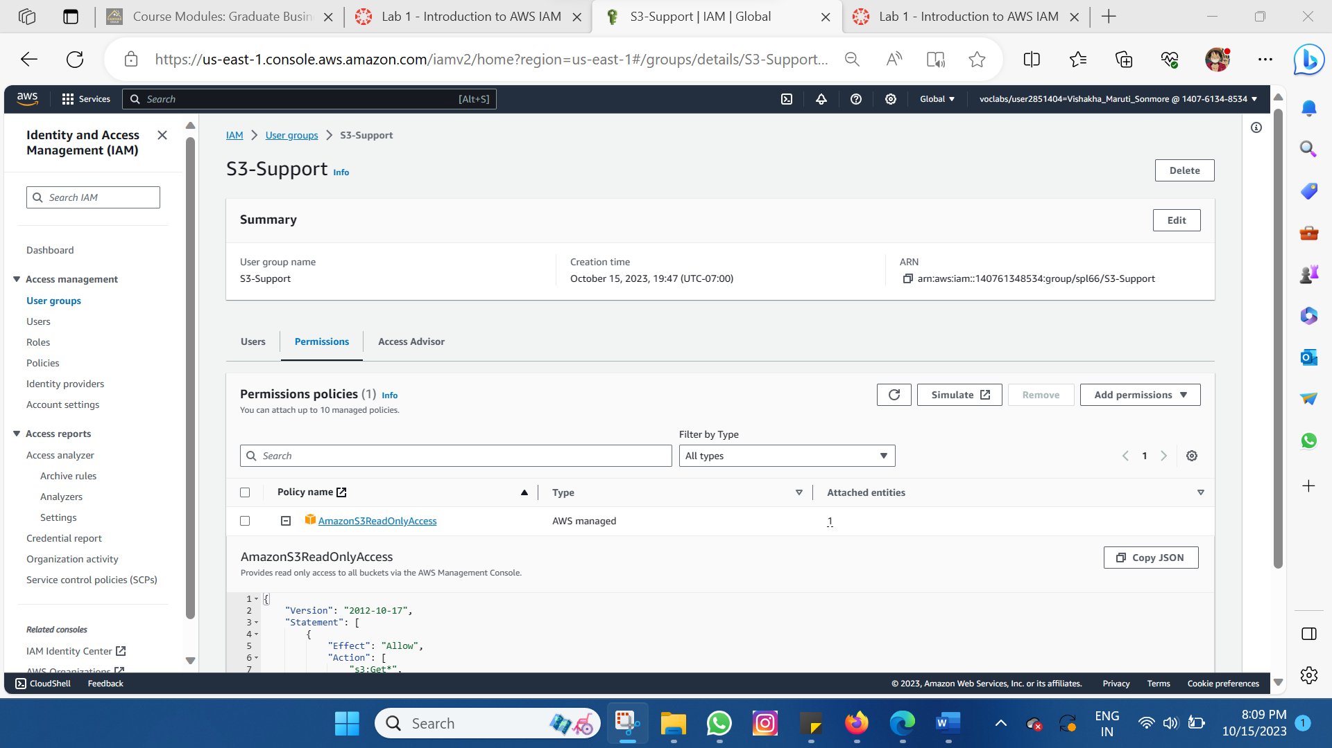

**Task 2: Add Users to Groups**

2.1 In the left navigation pane, choose User groups >> Choose the S3-Support group >> Choose the Users tab >> In the Users tab, choose Add users.

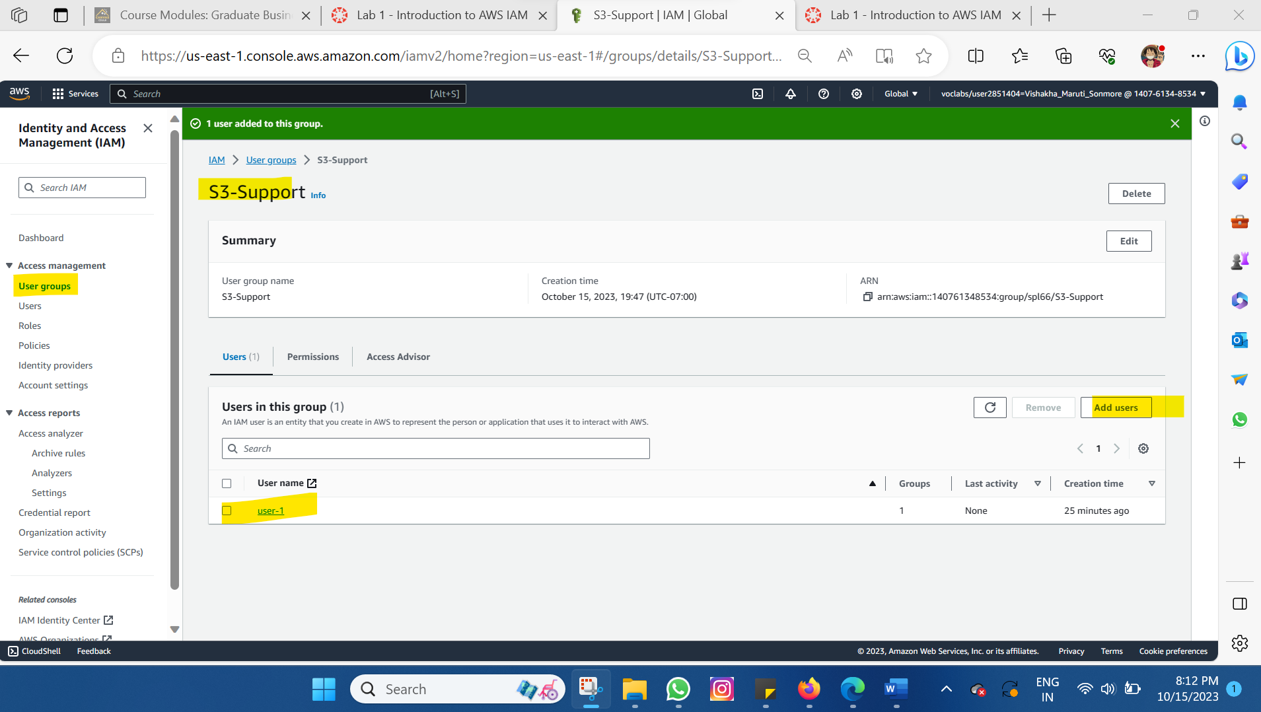

2.2 Add user-2 to the EC2-Support Group

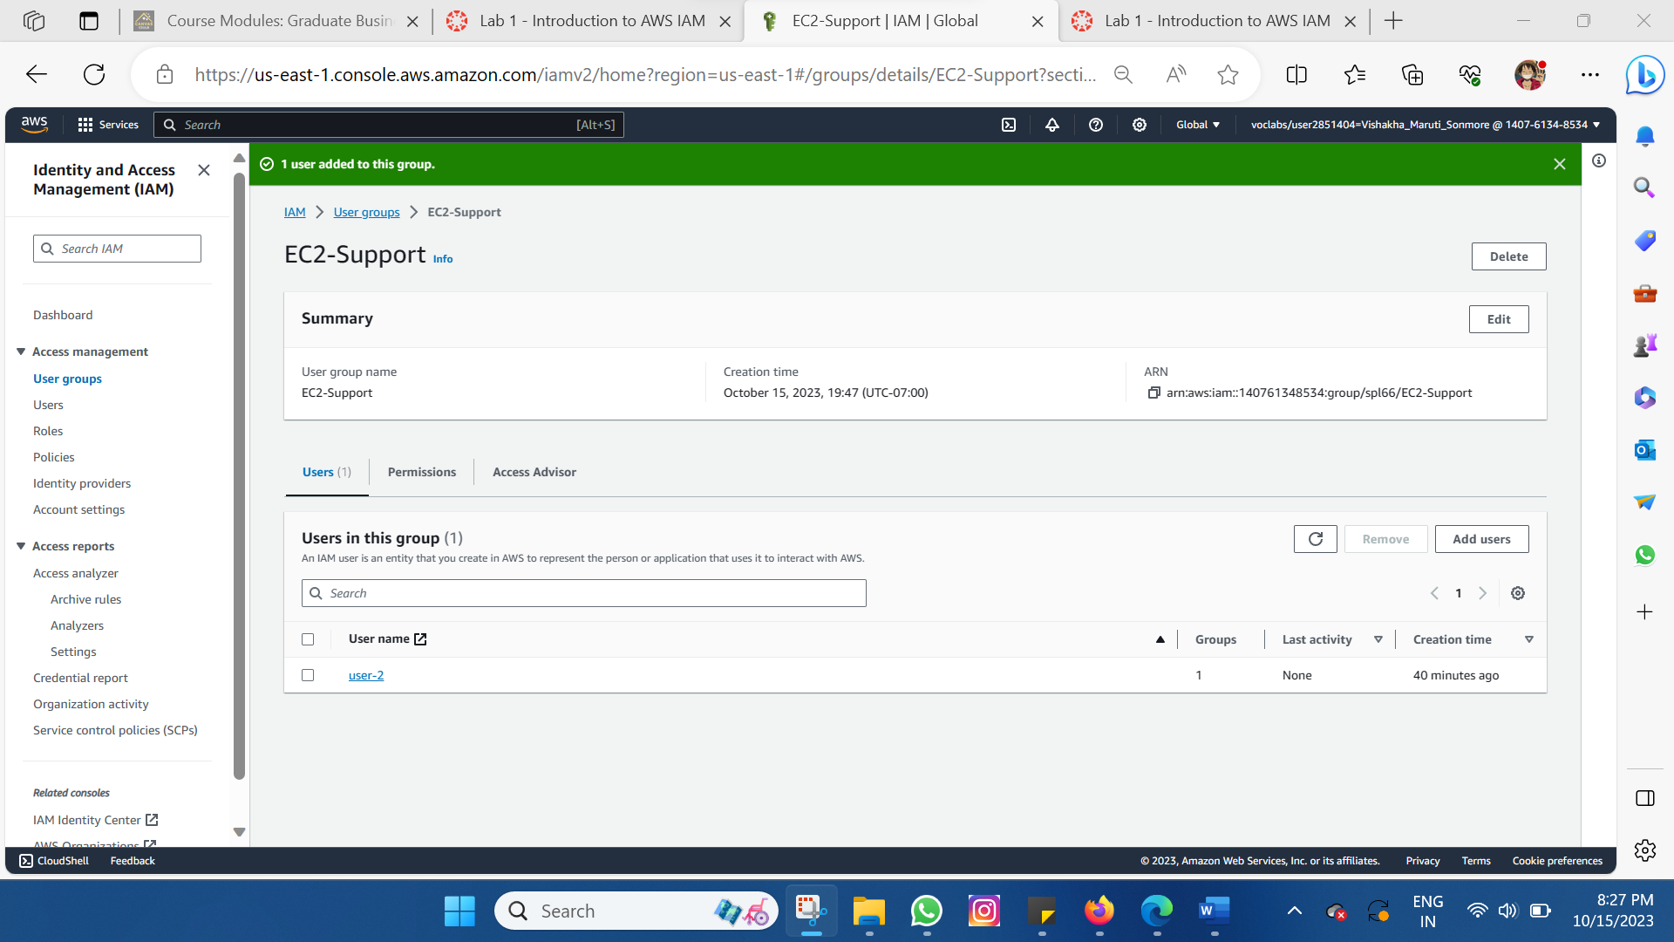

2.3 Add user-2 to the EC3-Admin Group

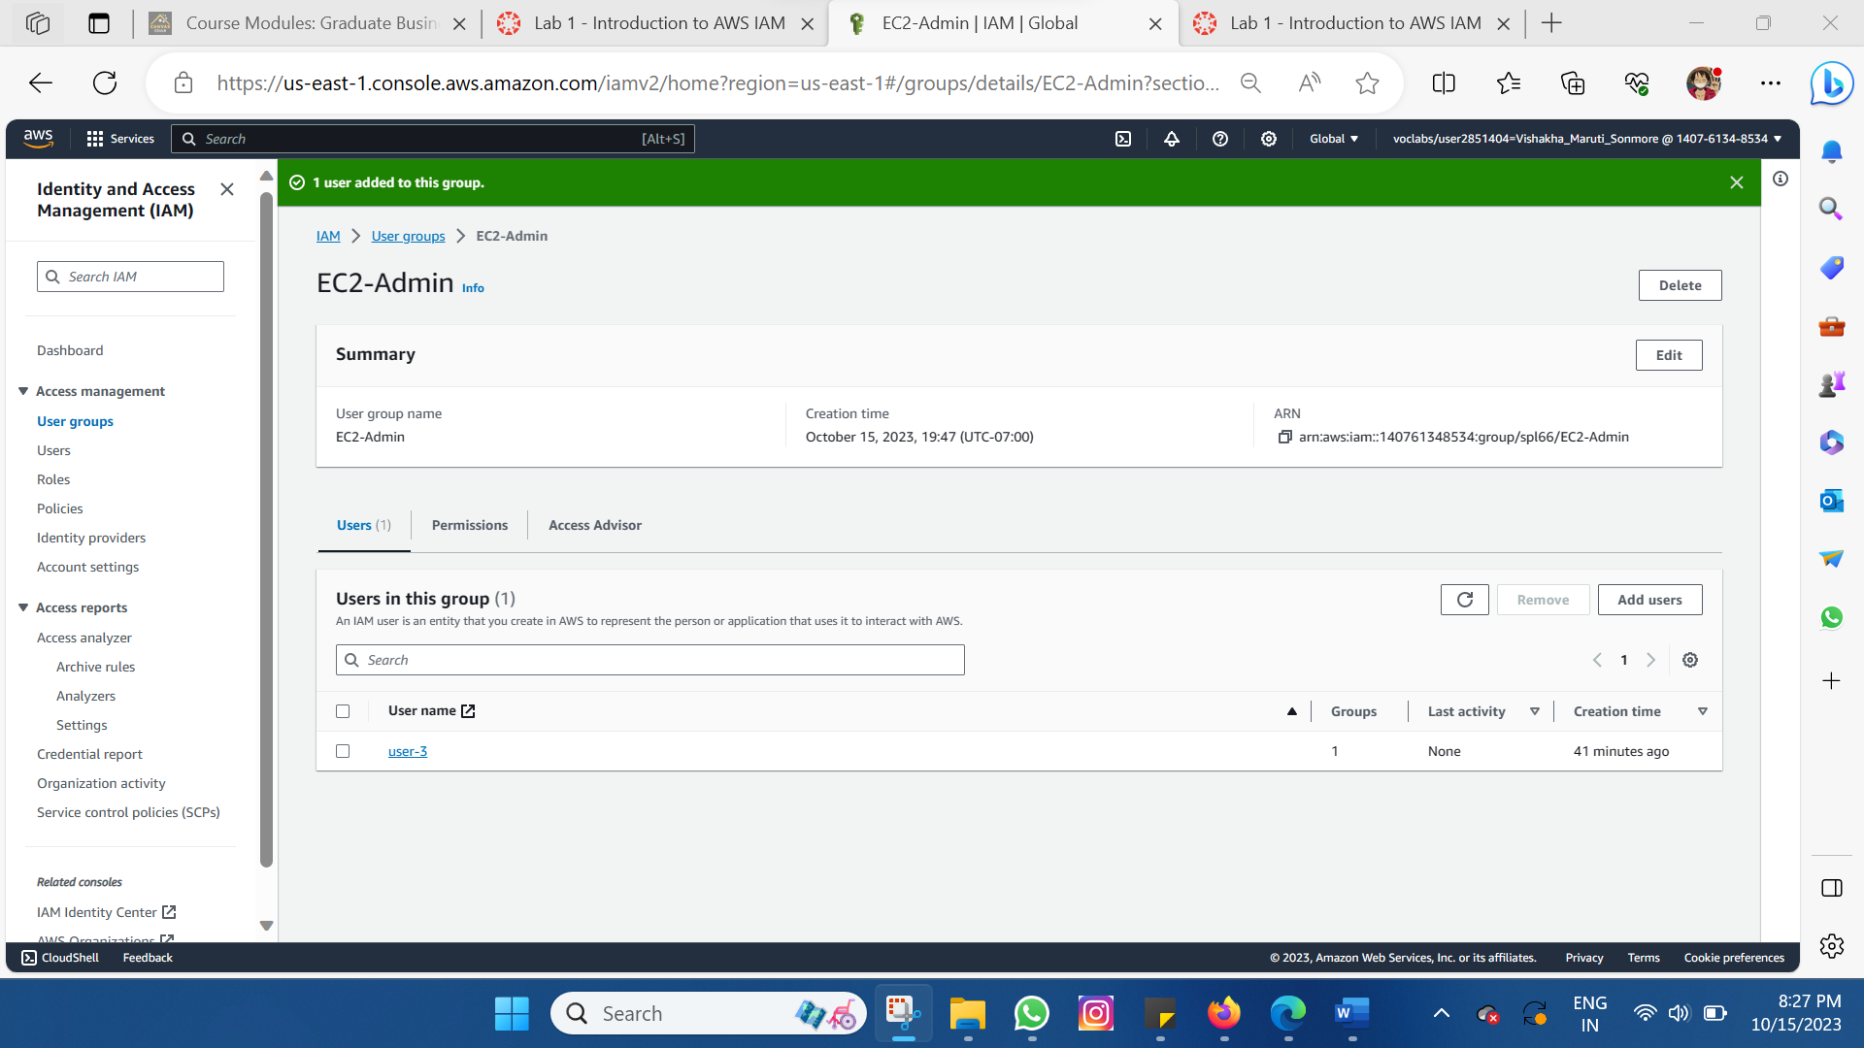

2.4 User Groups after adding users

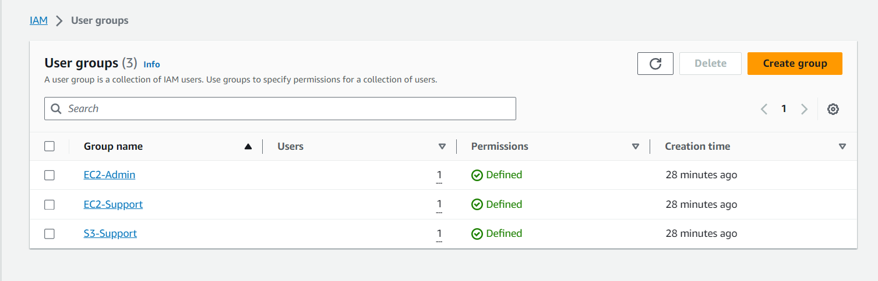

Users after getting assigned to the Groups

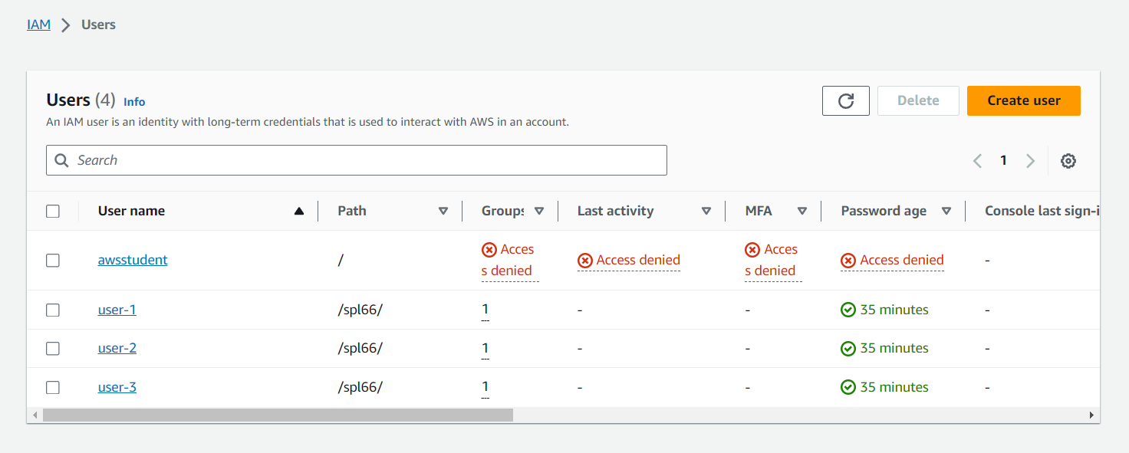

**Task 3: Sign-In and Test Users:** In the final step, you assess the access permissions of each IAM user by logging in as them and attempting to use AWS services. You verify if their permissions are in accordance with the specific business scenario. User-1, a member of the S3-Support group, is capable of accessing Amazon S3 but is unable to access Amazon EC2. User-2, belonging to the EC2-Support group, has the ability to access Amazon EC2 but lacks access to Amazon S3. User-3, who holds the role of EC2 administrator, is empowered to carry out actions such as halting an EC2 instance. This task serves as a practical demonstration of how IAM permissions are put into practice, and how user access is controlled or granted based on their assigned roles and group affiliations.

3.1 Sign in to user-1

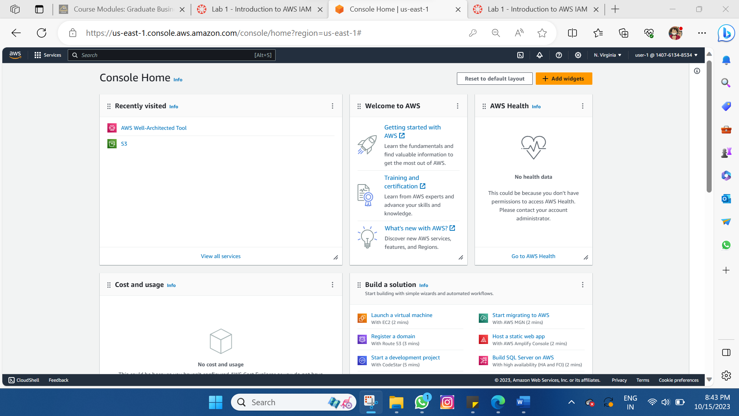

3.2 Choose the name of the bucket that exists in the account and browse the contents.

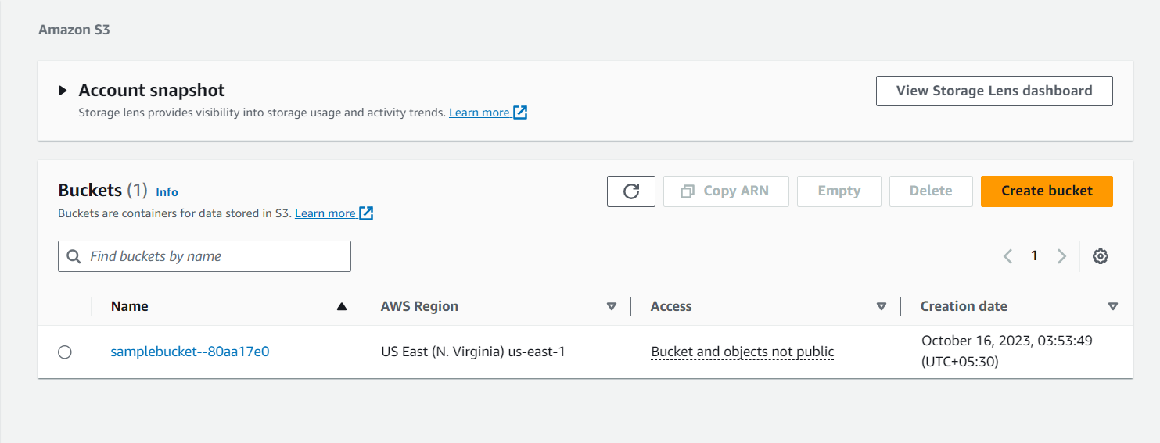

3.3 In the Services menu, choose EC2.

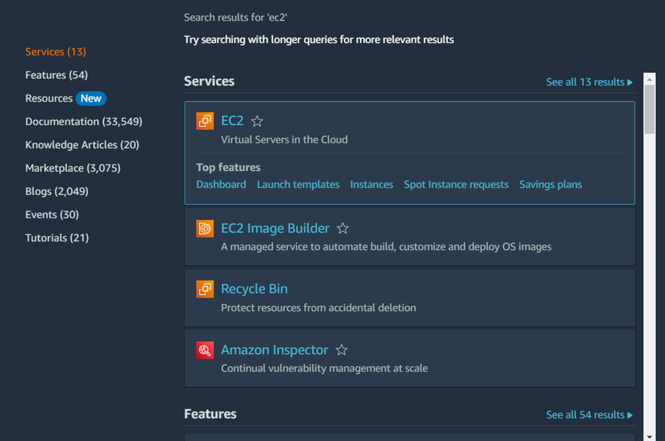

3.4 In the left navigation pane, choose Instances.

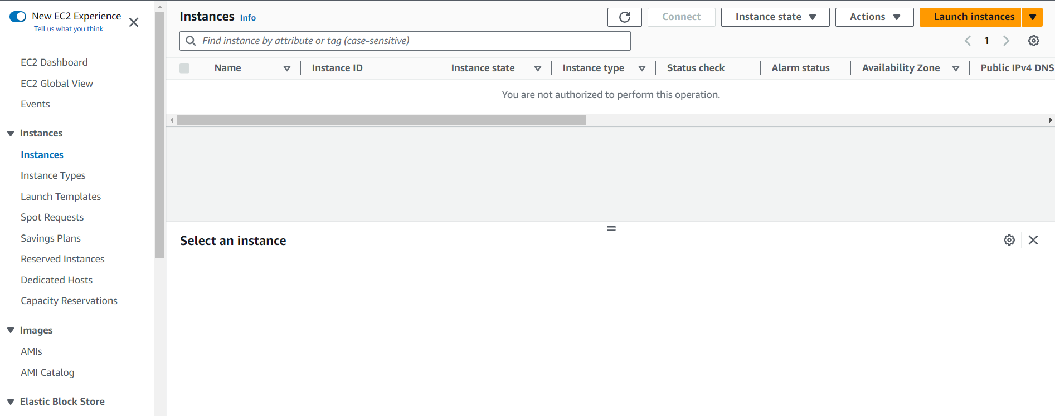

3.5 Logged out of user-1 account and login to user-2

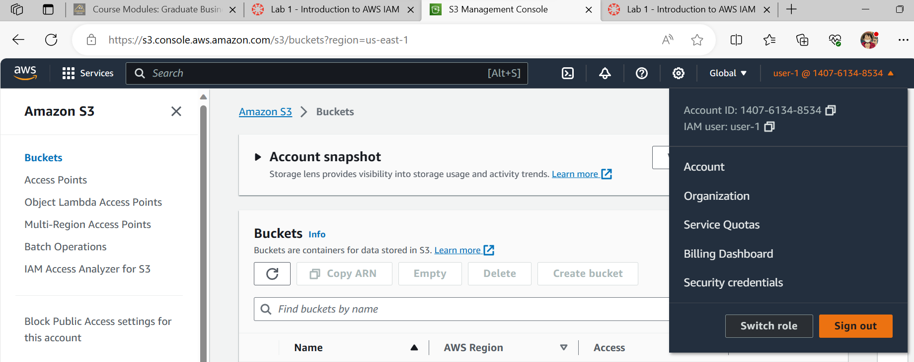

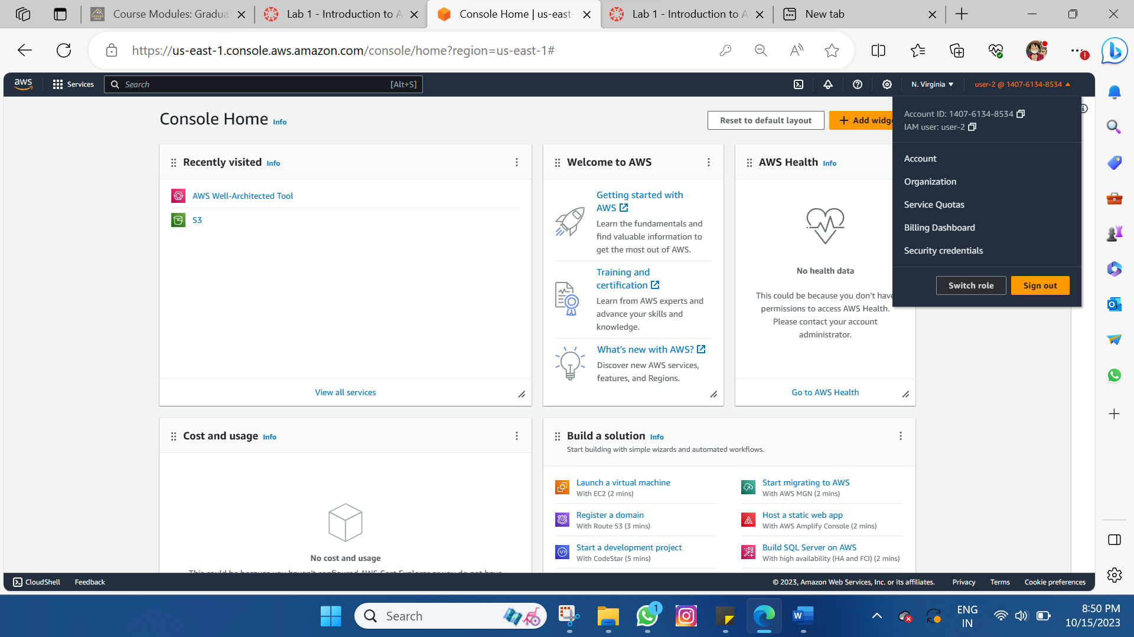

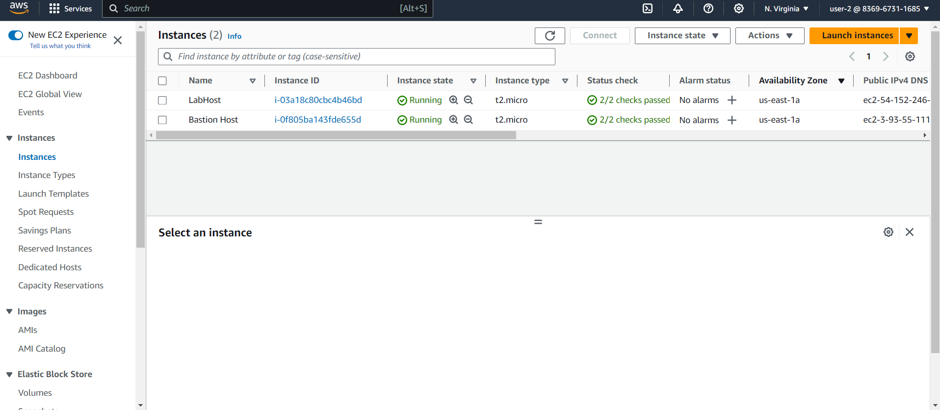

3.6 LabHost selected

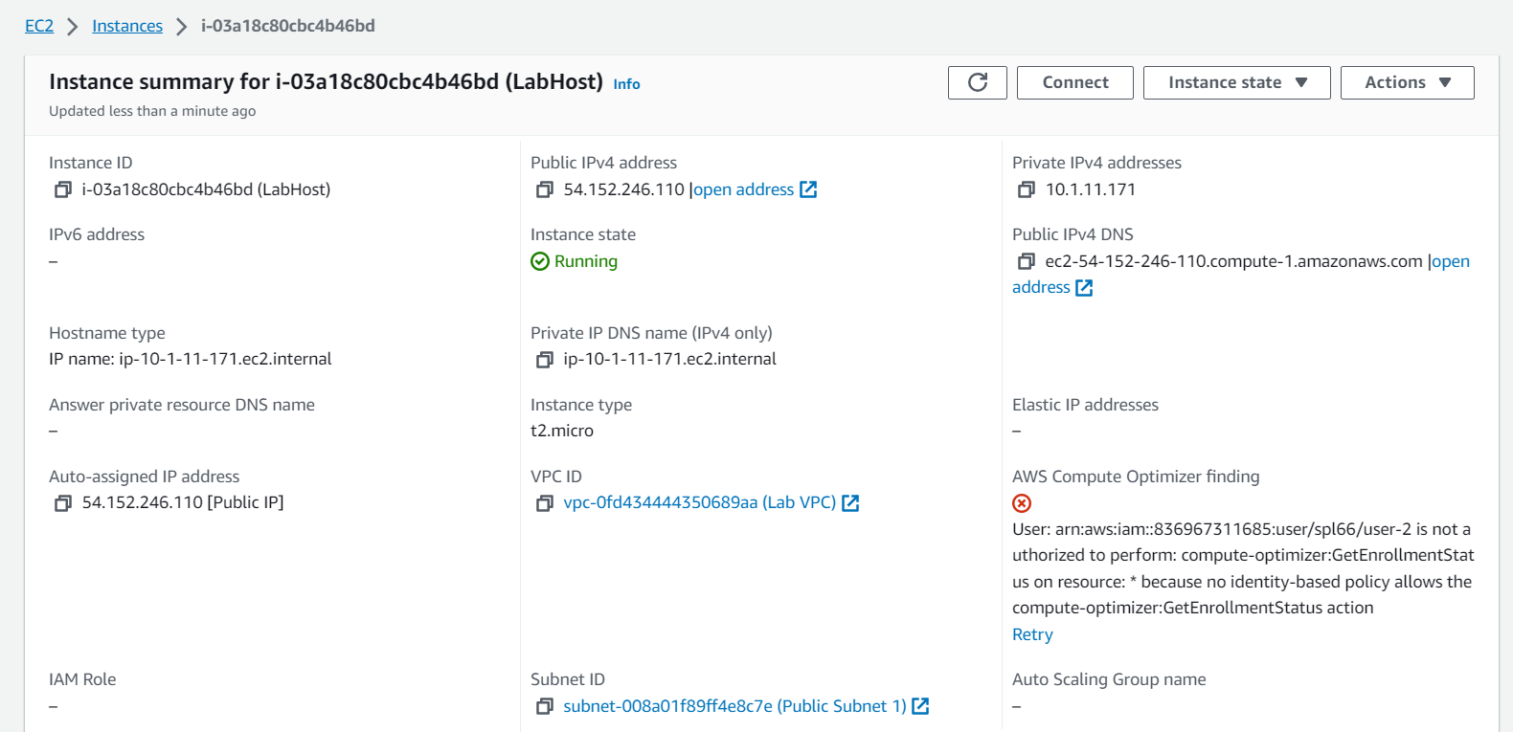

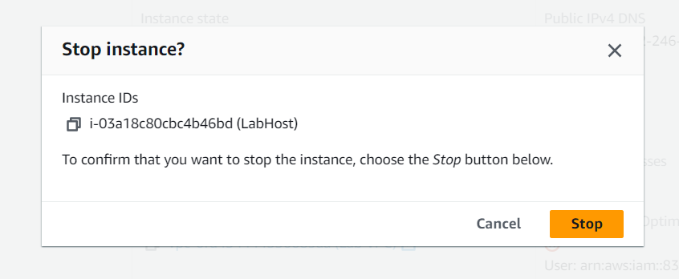

3.7 Stopping the instance failed & logging in to user-3 account

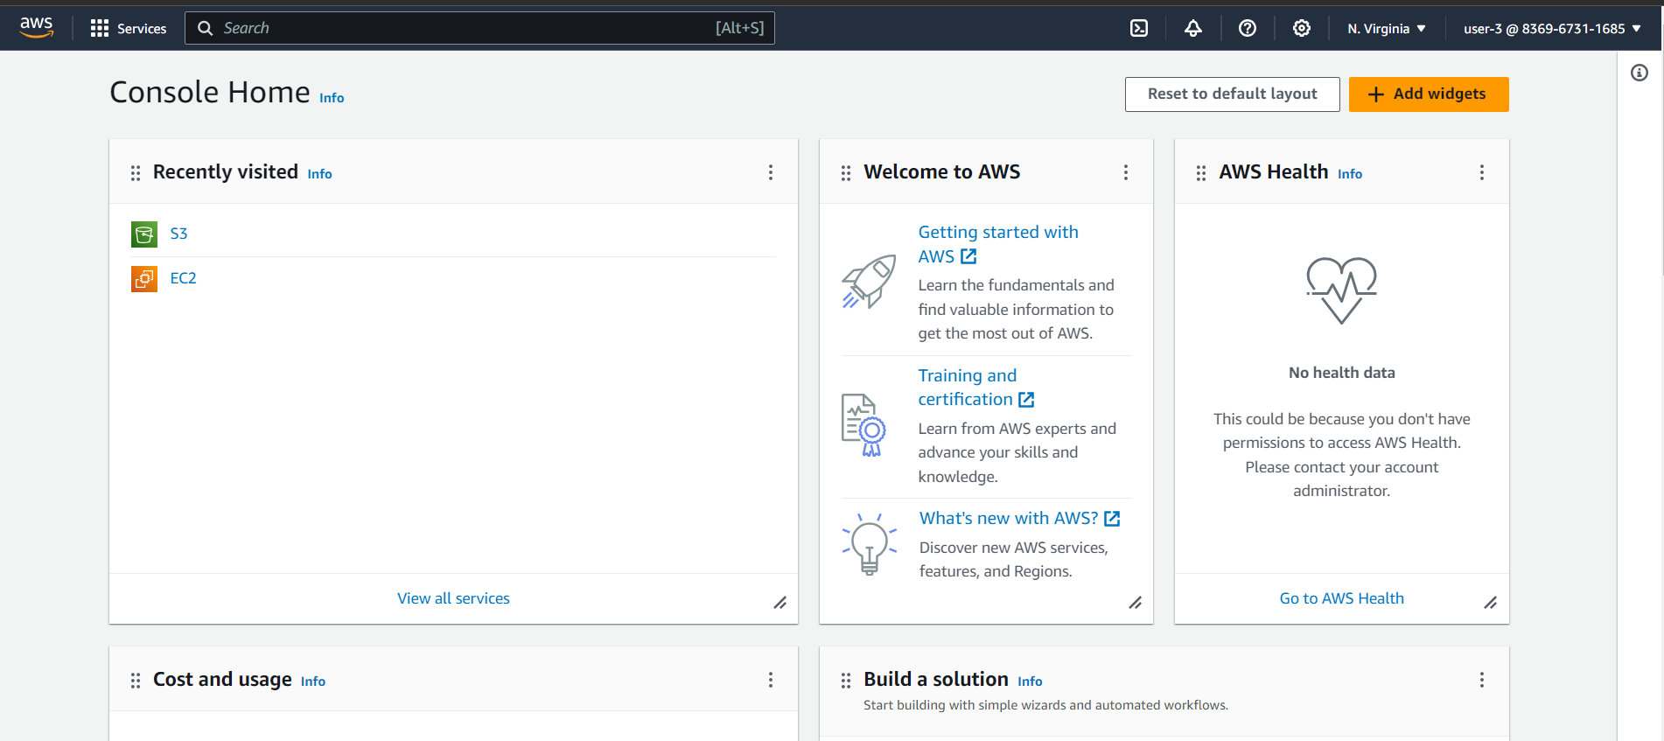

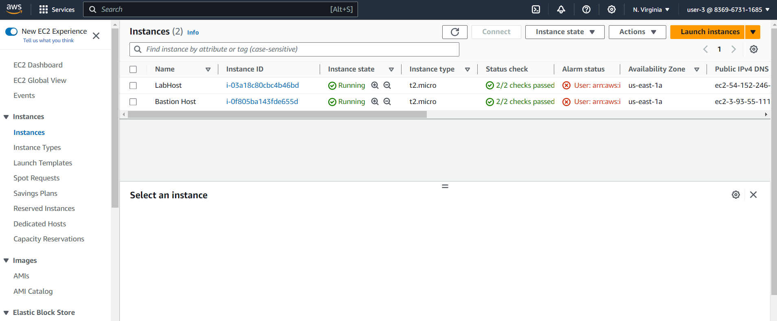

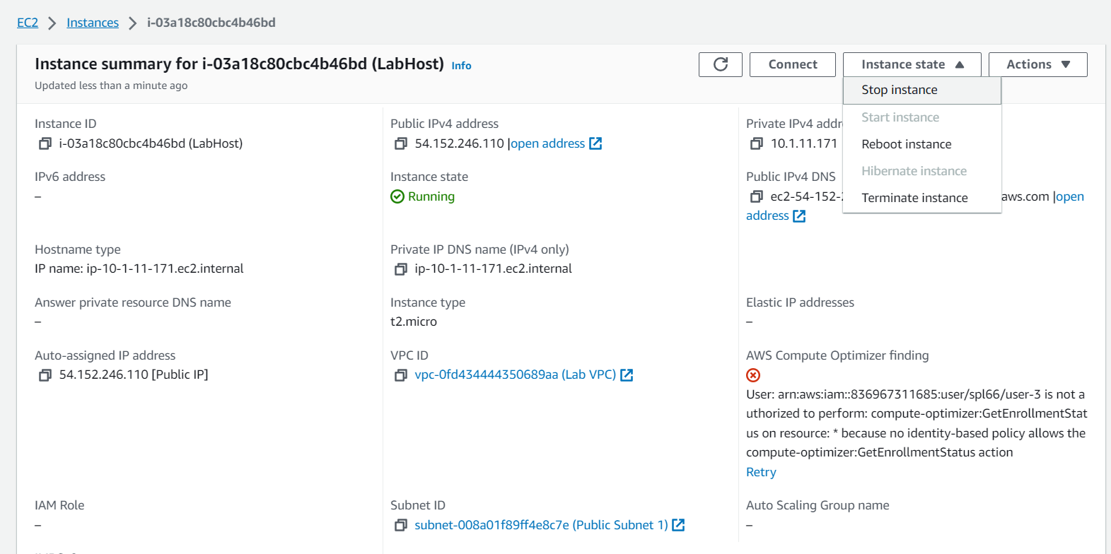

3.8 LabHost Instance stopped

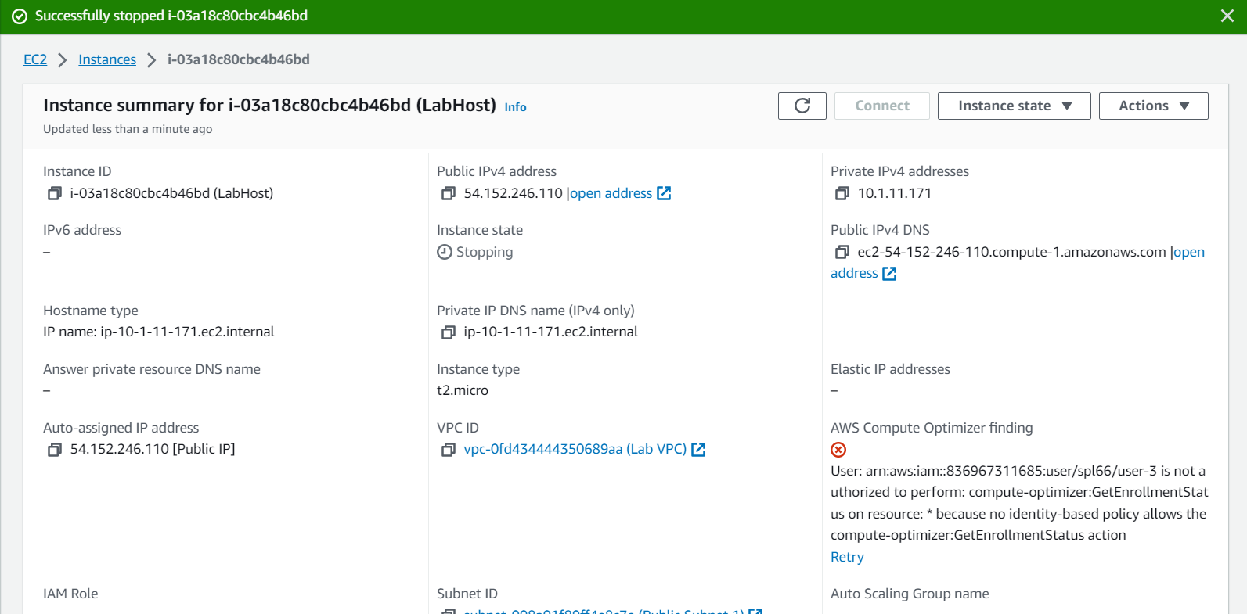

3.9 Log out and quieting the Lab

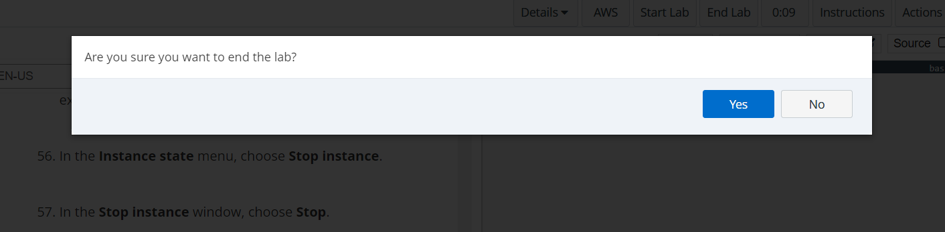

In summary, this laboratory offers a practical initiation to AWS IAM, illustrating how you can administer user access and authorization in the AWS environment to guarantee security and effective resource control.